RQHA west texas classic

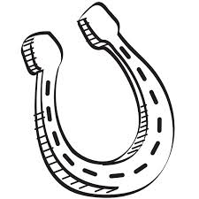
Friday, Saturday & Sunday
OCTOBER 5 - 7, 2018
3 days; 5 judges
Spur Arena, 200 West 43rd Street
San Angelo, TX
Show Manager: Denise Valles; 432-940-4256
Show Secretary: Nancy Jones; 432-940-6986

RQHA Inc.
P. O. Box 107
Midland, Texas 79702

HOST HOTEL: Baymont Inn & Suites, 1418 N Bryant Blvd, San Angelo; 325-617-7990;
$99/night (king or 2 queen) Must indicate Remuda Quarter Horse show rate
STALLS: $30.00/night Shavings $9.00 (must purchase at least 1 bag per stall); RV HOOKUPS: $35.00/night
STALL & RV RESERVATIONS: call or email Macy Schwartz @ 325-653-7785; macy@sanangelorodeo.com

ENTRY FEES:

$15.00 Per Class/$65.00 Maximum per Division; All Walk-Trot Classes $5 each (not included in maximum)
$5.00 obstacle fee per horse per show day for all trail entries
$6.00 Office Fee Per Person/$5.00 AQHA Drug Fee Per Horse/Per Show
Any exhibitor entering a Novice Youth class may enter the corresponding Youth class for free.
Any exhibitor entering a Novice Amateur class may enter the corresponding Amateur/Amateur Select class for free.

All Around Awards To Each Division: Same Horse/Same Rider Combination
Entry into halter classes NOT required for all-around, however halter points will count towards all-around in divisions offering halter classes. (In the event of a tie in Novice & Select classes - halter points will be used). Points earned in green classes are NOT included towards all-around. Contestants must compete in 3 or more classes in that division to be eligible for the all-around award.

RQHA INC.
Board members and/or workers will not be held liable for any accidents or loss during shows per AQHA rules and regulations

